\\ 21SW104

\\Task with Output

[\\OUTPUT](file:///\\OUTPUT)

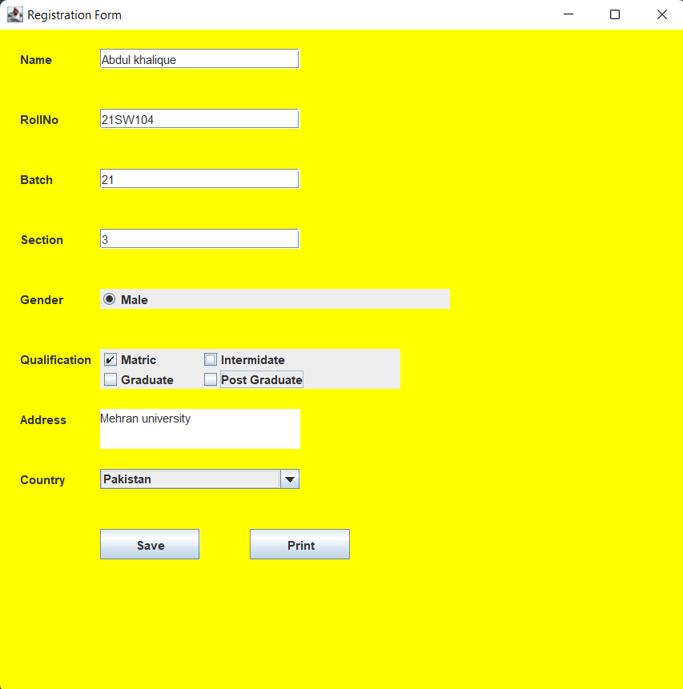

[\\NEW](file:///\\NEW) FRAME FOR PRINT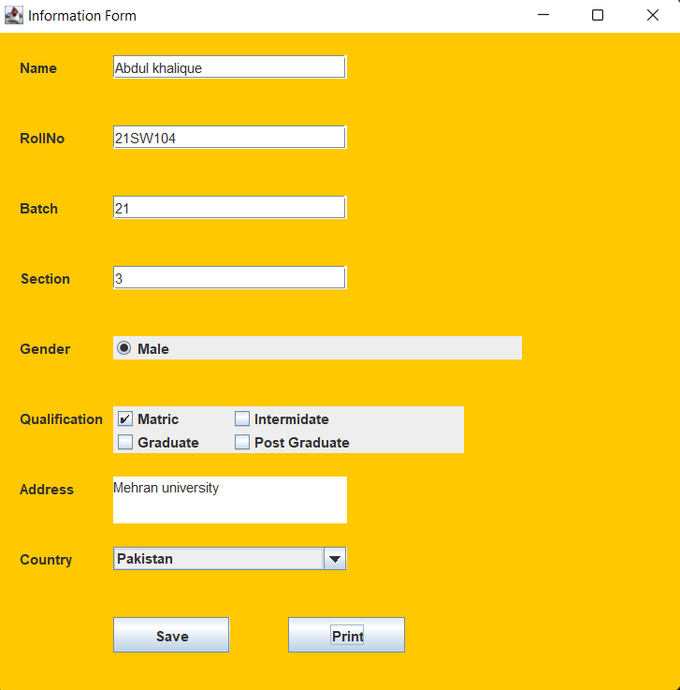

[\\OUTPUT](file:///\\OUTPUT) IN JSON FILE

